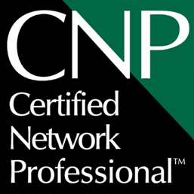

CNP Torch Bearer Program
Nomination Form

The Network Professional Association (NPA) International Board of Directors is seeking nominations for the CNP Torch Bearer Program. Nominees should be senior members of the computing profession who have made an outstanding contribution to the advancement of the profession or the industry by demonstrating that they embody the spirit of the CNP. Those who meet the standard will be awarded waivers of fees and/or requirements. Those who are selected to be CNP Torch Bearers are expected to promote the CNP as well as the NPA and its objectives within their sphere of influence.

Nominees go through a selection process which includes a thorough due diligence process before being designates of the CNP Torch Bearer Program. All new CNPs awarded in this manner will be contacted by the NPA executive director to ensure that they are willing to accept the title and obligations associated with the CNP title including completing elements of the application for our records.

If you have any questions, please either email them to cnp@npa.org or call 888-NPA-NPA0

Please send completed Nomination Form(s) by the first day of the Quarter to the Certified Network Professional Program Director at one of these addresses:
Mail:
Certified Network Professional
Program Director
1401 Hermes Lane
San Diego, CA 92154
Fax: 888-NPA-NPA0
Email: cnp@npa.org
CNP Torch Bearer - Nominator (Contact Person:)
Name of the Nominator:
NPA Membership Number:
Address:
City:
Province/State:
Country:
Postal Code/ZIP Code:
Telephone:
Fax:
E-Mail:

Nominee:
Name of the Nominee:
NPA Membership Number:
Address:
City:
Province/State:
Country:
Postal Code/ZIP Code:
Telephone:
Fax:
E-Mail:

Reason for the Nomination:
Please provide a 500 word (maximum) description of the contribution the nominee has made to the advancement of the profession or the industry on a separate sheet and attach it to this nomination form. The nomination must clearly outline the contribution of the nominee to the computing profession and industry over a substantial and sustained career and these contributions must embody the spirit of the CNP.
Certification:
I declare that all information provided in support of this nomination is accurate to the best of my knowledge:

Nominator Signature: ____________________________

Date: ____________________________

